INTERNATIONAL TABLE TENNIS CAMP – BANJA LUKA 2022
Banja Luka city and table tennis club „Spin“ will organize International table tennis camp in period from June 26th, 2022 to July 3rd, 2022.
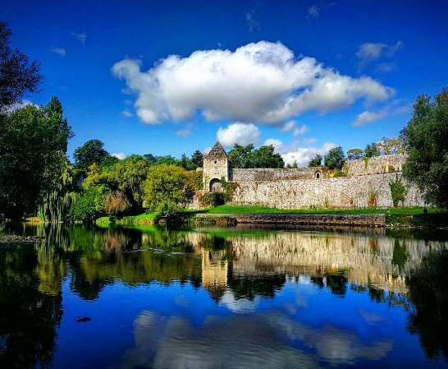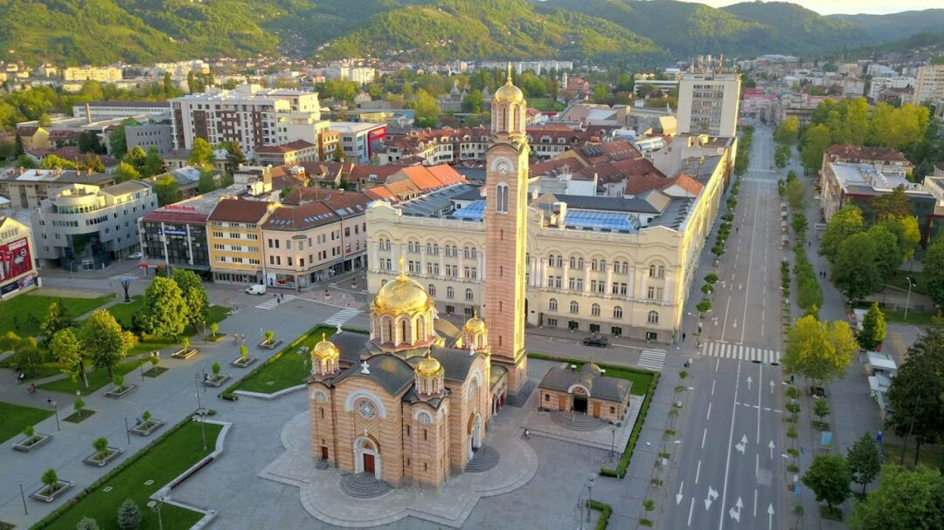
ABOUT CITY
Banja Luka is located in a valley at an altitude from 164 meters. The city belongs to central European time zone and has got moderately continental climate, with dominante influence of pannonian region. Banja Luka was recognized as a city of sport and youth who has a long sport tradition.
ACCOMMODATION
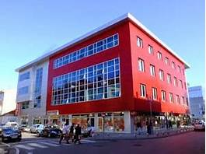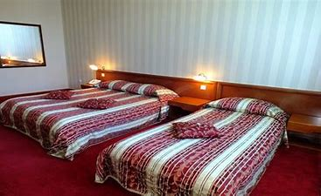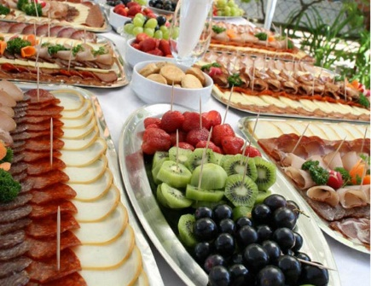
We provide full board (bed, breakfast, lunch and dinner) in Vidovic Hotel **** set in Ivana Franje Jukica 11. street in the city center, 50 meters from the main city square. There is a free garage, full video surveillance, restaurant a-la-carte, café. All main stores and shopping centers are there, few minutes from the hotel. Rooms have flat-screen TV-s, air conditions, work-desk, minibar. Bathrooms are equipped with towels and hairdryers.

MAIN COACH
Joze Urh is a famous Slovenian coach. He works in a Tibhar table tennis center in Saarbrücken, Germany. Homonymous club competes in the German Bundes League that represents the strongest European table tennis League. As a coach he achieved notable results on a world`s and Europe`s level. As the most important results is a first place on a World`s List of Juniors, his player, Jorgic Darko. Urh won witt Senior National Team of Slovenia, bronze medal on a European Team Championship. His longterm work in Italy he crowned in 2010 when he and Mutti Leonard became first in a cadet category. He maintain a large number of table-tennis seminar, under patronage of ETTU.
FITNESS COACH
Tomislav Tepic is Croatian expert from Cernje – Vinkovac. He graduated kinesiology in 2009. After grauation he started with work in a football club Cibalia. He started with seniors and worked for 2 years.
In 2017, he signed contract with Chinese table tennis association. He becomes Ma Long`s first conditioning coach. Ma Long defended gold medal on the Olympic games in singles and he become World Champion two times.

ASSISTANT COACHES
Sinisa Marcetic and Dragan Vucic – licensed coaches, began their work in 2014, with the youngest in Youth Table tennis club “Spin”. They affirmated and produced a few National team players of Bosnia and Herzegovina. Bosnian Table tennis alliance assigned them table tennis license.
Also, the organizer provide them a large number of sparring partners. Some of them are National team players in Serbiaand Bosnia in Junior and Senior category.

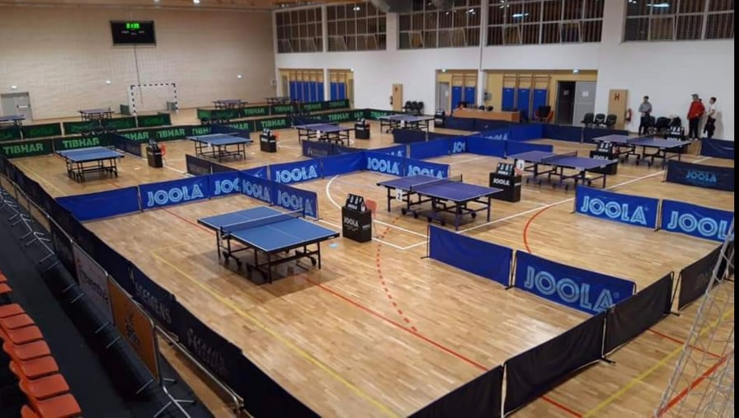
HALL
Trainings will take place in new sport`s hall “Centar” in Jevrejska 87. Street, just a 100 m far from Hotel Vidovic. The hall disposed with 20 professional competition JOOLA tables, 6 lockrooms with showers, airconditioning and led-ligts.

WORKING PROGRAM - AGENDA
At Sunday June 26th, 2022 all competitors will arrive until 19.00 o `clock in accommodation – Hotel Vidovic in Banja Luka. At 19.00 o`clock all competitors will have a meeting where they will be informed about detail activity schedule of the camp. Everyone will get a card where they will find all techniques and tactics that their trainers observed. Trainings will take place two times a day , in the morning and evening from June 27th – July 1st, 2022 and one fitness training per day.
At Saturday, July 2nd, 2022 competition for participants will take place , as a seminars:
- “Tactics in table tennis “
- “Techniques changes related to plastic balls”
- “Fitness preparation for table tennis competitors”
Joze Urh and Tomislav Stepic will be teachers.
ADDITIONAL ACTIVITIES
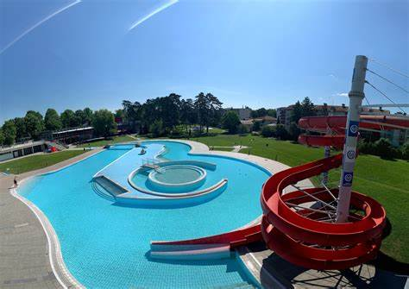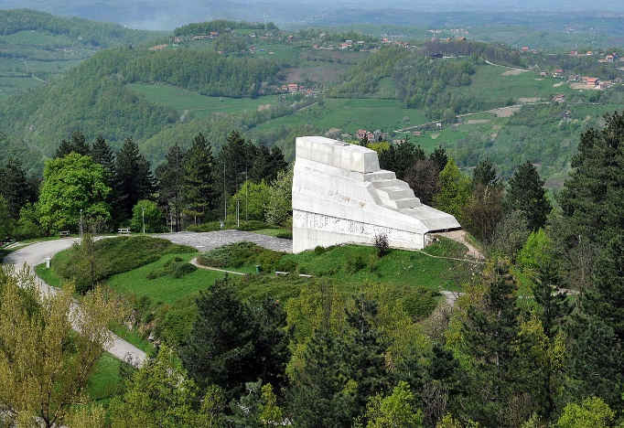
The organizer provided tickets for Aqua Park “Aquana”, for all participants.
Aqua Park is settled near the Hotel Vidovic, in Borik. There are three swimming pools. There is also toboggan a 100 m long, a water way vortex in a pool and many fountains, massage blades and massage jets. Total water areas are 1500 m², there are green cascades and natural shade (long 24000 m²). The latest installment of water cleaning are garancy for hygienic quality impeccable water purity that changes 5 times per day. Water is 26-28 pleasant degrees. In same compex are also two beach volley and two basketball terrains, pizzeria and grill.
It will be organized a picnic on a beautiful Banj Brdo hill, where you have a fantastic view of city Banja Luka. The top of the hill is just 5 km distance from the city center.

PRICE AND PAYMENT
The price of the camp is 250 €.
Includes whole training process, full board in a Hotel Vidovic (bed, breakfast, lunch and dinner) incuding taxes and insurance, Aqua Park tickets, and one day picnic on a tourist attraction Banj Brdo – Banj Hill.
The price of seminar is 25 €. All participants of the camp get the 50% discount.
Payment can be made by cash on arrival, or by the transaction and foreign currency account.
The camp can be payed by four installments:
- March 70 €
- April 60 €
- May 60 €
- June 60 €

Transaction account for BiH (BAM): 552-002-0002-361333 (Addiko Bank)
Instructions for EUR payments:
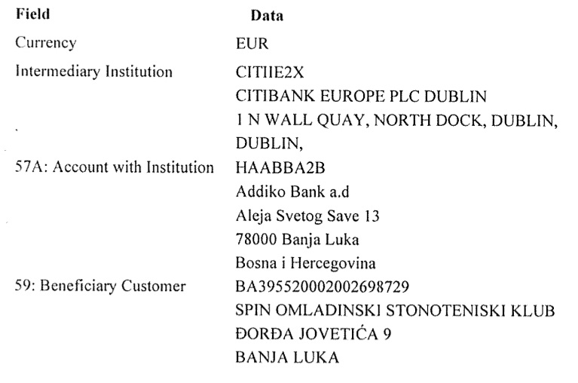
INFORMATION AND CONTACT:
All additional informations you can achieve by:
- E-mail: ostkspin@gmail.com
- Sinisa Marcetic 00 387 65 969 366 (Viber, WhatsApp)
- Dragan Vucic 00 387 66 419 195 (Viber, WhatsApp)

